Week 8

8.1 | Understanding Business Requirements

40 minutes
In today's rapidly evolving business landscape, the ability to synthesise and communicate complex data through effective visualisation and storytelling has become a pivotal skill for professionals across various sectors. As businesses increasingly rely on data to make informed decisions, there is a growing demand for innovative educational tools that can equip professionals with these critical skills. This challenge recognises the unique opportunity to leverage Generative AI (GenAI) technologies to develop an intelligent chatbot designed to meet this need. By understanding the specific business requirements and conceptualising the design of such a solution, you will embark on a journey to bridge the gap between technological potential and practical application in professional education.
The exploration begins with a deep dive into the existing landscape of educational technologies, specifically those powered by AI, to identify the strengths and limitations of current offerings. This investigation is not just about understanding what exists but about envisioning what could be.

The challenge
You will conduct research to analyse available products and solutions. You will then identify business requirements for the chatbot, and compare existing solutions.

The output
A slide deck summarising your market research, business requirements, and competitive analysis.

The task
In this task, you will conceptualise a chatbot that teaches data visualisation and storytelling. You will analyse available products and solutions, then identify business requirements for the chatbot, and compare existing solutions. You will present your findings in a short slide deck.
Before you begin this task, review the project description below:

DataInsight Copilot Case Study
Download DataInsight Copilot Case Study
Important notes: DataInsight Copilot case study is used in the activities this week to help you understand the requirements and expectations for build AI solution. DataInsight Copilot is not the case study used in Assessment 2.

Instructions
Review the task materials, then create your slide deck in the following format:
- Market Research and Analysis:
  - Begin with identifying existing GenAI-powered chatbots that are designed for educational purposes, particularly those focusing on data visualisation and storytelling.
  - Utilise databases, industry reports, academic journals, and product reviews to gather comprehensive information. Pay special attention to chatbots used in professional development and training.
- Identify Business Requirements:
  - Define the target audience for your chatbot, including their professional background, learning needs, and challenges in data visualisation and storytelling.
  - Determine the learning objectives that your chatbot aims to achieve and the key functionalities it must have to meet these objectives effectively.
- Competitive Analysis:
  - Evaluate the identified chatbots against a set of criteria such as user engagement, pedagogical effectiveness, technological innovation, and scalability.
  - Highlight what these solutions do well and where they fall short, focusing on features that enhance learning outcomes.
  - 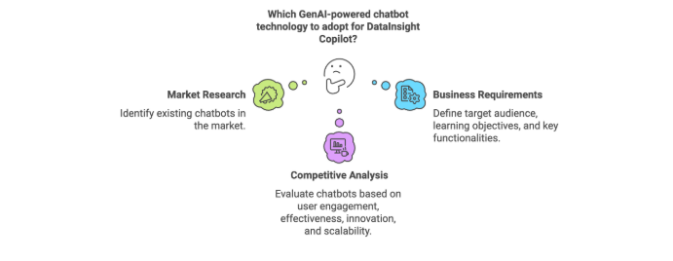

Prepare to share your output in the class.

Watch: AI Agent Design Considerations for DataInsight Copilot Case Study

Supporting resources
Below are a number of AI tools with learning mode that can be reviewed as options for building Datainsight Copilot
Heymans, M. (2025). Guided learning in Gemini: From answers to understanding.
Links to an external site.
The Keyword.
OpenAI. (2025). Study mode [AI platform feature].
Links to an external site.
Google. (2025). NotebookLM: Learning Guide mode [AI platform feature].
Links to an external site.
Google.

Week 8

8.2 | Conceptual Design and Data Integration

40 minutes
Creating a chatbot that effectively teaches data visualisation and storytelling requires a deep understanding of how to design its interactions and content delivery. This includes integrating real-time data to provide hands-on, practical learning experiences. In this challenge, you need to come up with a conceptual design for the DataInsight Chatbot, detailing the chatbot's core functions and conversational flow. You also need to identify the data source required to provide useful knowledge for the chatbot.

The challenge
You will design a conceptual framework for your DataInsight Copilot chatbot to establish user flow, core features, and data integration—critical for effective engagement and impactful content delivery.

The output
A slide deck summarising your conceptual design of the chatbot and plan for data integration.

The task
In this task, you will design a conceptual framework for your chatbot that outlines its core functionalities, user interaction flow, and data integration capabilities. You will consider how the chatbot will use data to teach, challenge, and provide feedback to learners. You will then present this in a slide deck for use in Assessment 2.
Before you begin this task, review the following materials about the components you will need to address:

Design Core Functionalities
Outline the chatbot's primary functions, including content delivery methods, interactive exercises, and feedback mechanisms.
Visit the following resources for further information:
- https://www.revechat.com/blog/chatbot-features/
- https://shakurova.io/blog/chatbot-development-best-practices/

User Interaction Flow
Create a flowchart that details the user's journey through different learning modules, highlighting points where data integration enhances the learning experience.
Visit the following resource for further information:
- https://helpcrunch.com/blog/chatbot-conversation-flow-example/

Data Integration Plan
Specify the types of data your chatbot will use, the sources of this data, and how it will be integrated into learning activities. Think about that data or knowledge that will make the Chatbot more useful.
Watch the following resource for further information:

Instructions
Review the task materials, then complete the following steps to create your slide deck:
- Illustrate your conceptual design using diagrams and flowcharts to visualise the chatbot's architecture and interaction flow.
- Document your plan for integrating data, including technical requirements and potential challenges.
- Prepare a brief presentation or report that summarises your conceptual design and data integration strategy in the live class. You will need to include a justification for your design.

Be prepared to discuss your insights in the live class.

Supporting resources
Chatbot technologies are changing rapidly. For ideas about structuring your framework, review the following resources:
- AI-powered Chatbot: Conceptual framework example
- MS Copilot Studio Overview

